

PROJECT: MINDFUL INTENTIONS
GROUP NO:05 BATCH:T5.2309.E0

A. SYSTEM REQUIREMENTS:
Sr. | Item | Description
1. | Operating system | Windows 7, 8, or higher
2. | Hardware | - A minimum computer system that will help you access all the  tools in the courses is a Pentium 166 or better.  - 64 Megabytes of RAM or better
3. | Web Browser | Version in later of: Edge 44, Firefox 40, Chrome 55, etc…
4. | Fonts | Standard font Unicode: Arial, Tahoma, Lucida Console, Times New Roman, etc…
5. | Other requirement | A working internet connection.
Notes: Do not install IDEs (Integrated Development Environment) on the system such as MS Visual Studio, Jbuilder, Dreamweaver, etc.

B. Program Instrallation

Step 1. -Open link GitHub: https://github.com/TruongVoHuuHuan/MindfulIntentions_Group05
-Or copy the link,open link on browsers like Chrome, Google,... The screen result will display like this:
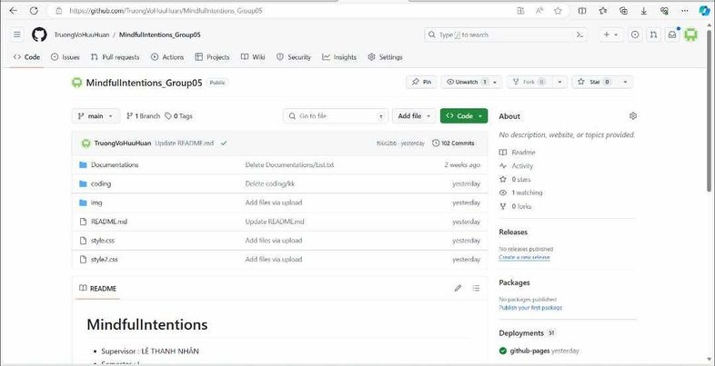

Click on the Code button as shown:
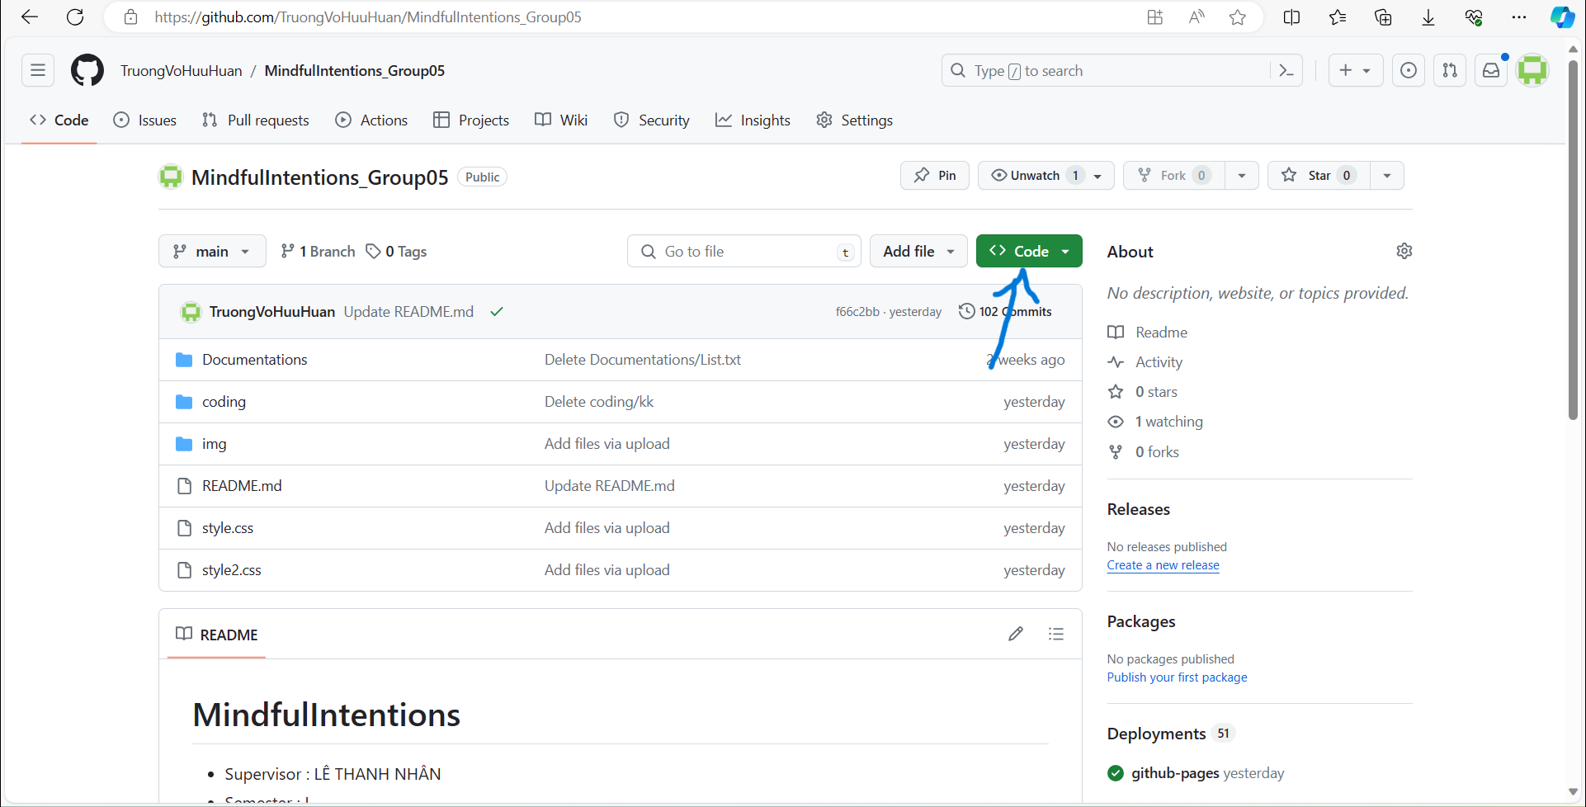
Click Download Zip:
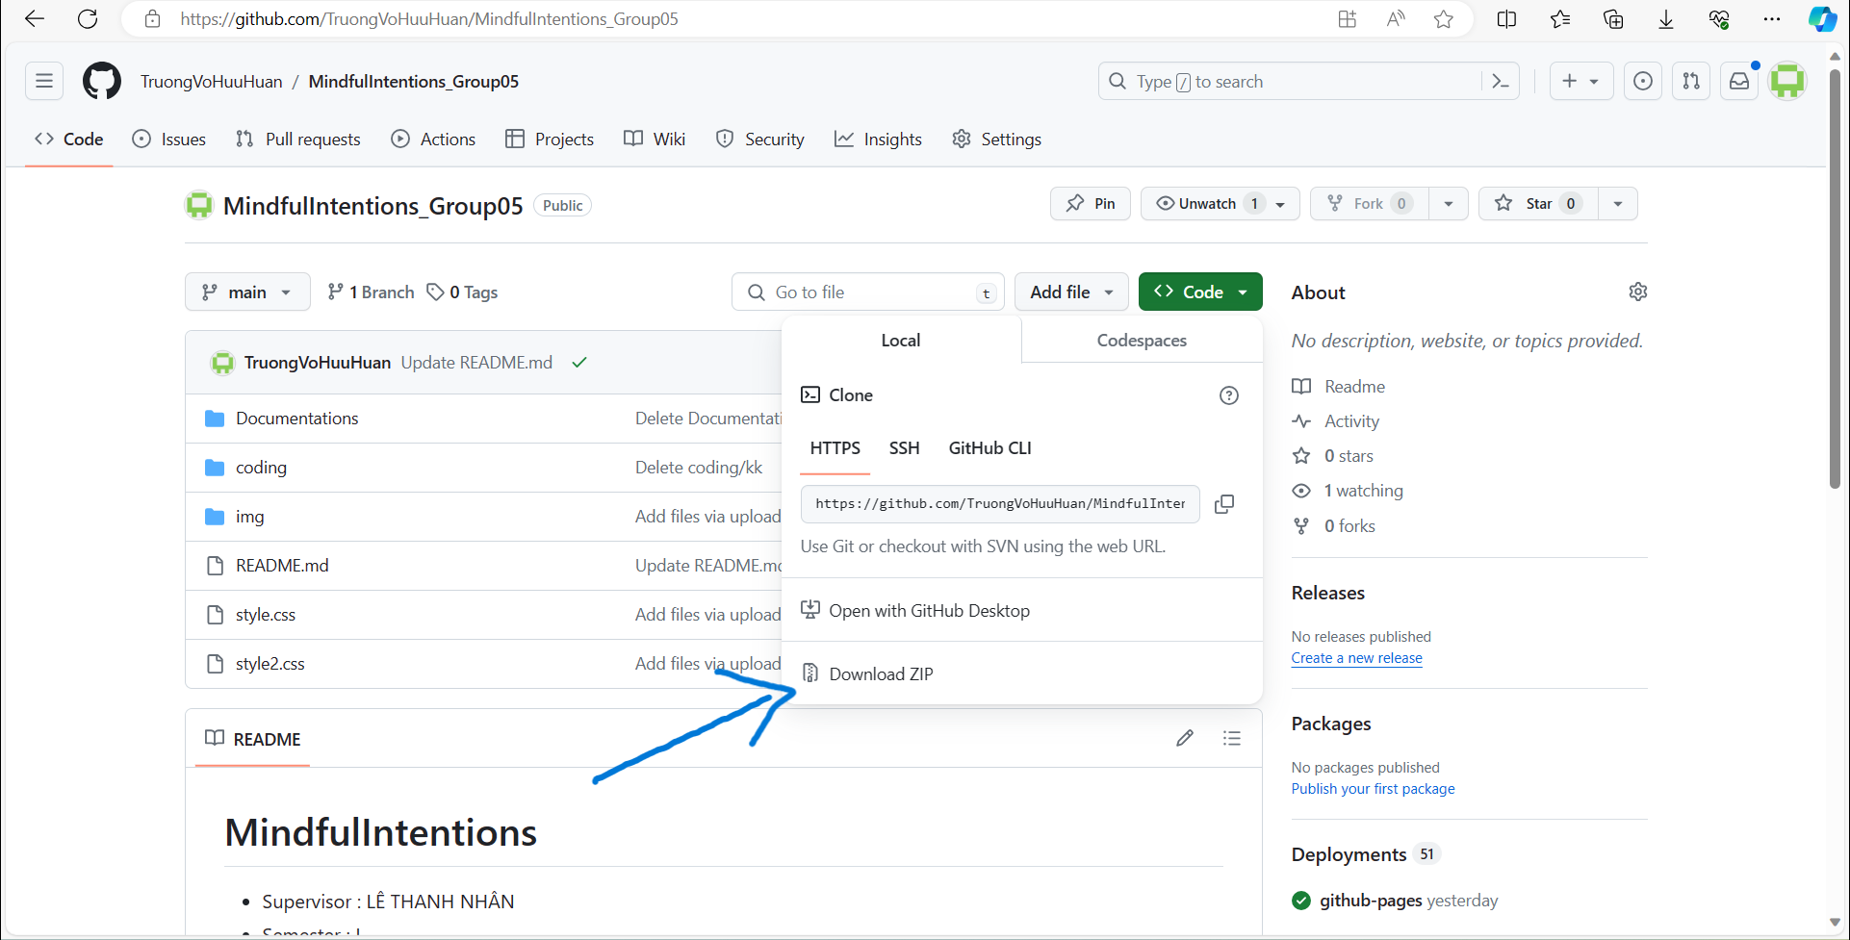
Step 2. Go to your computer's downloads:
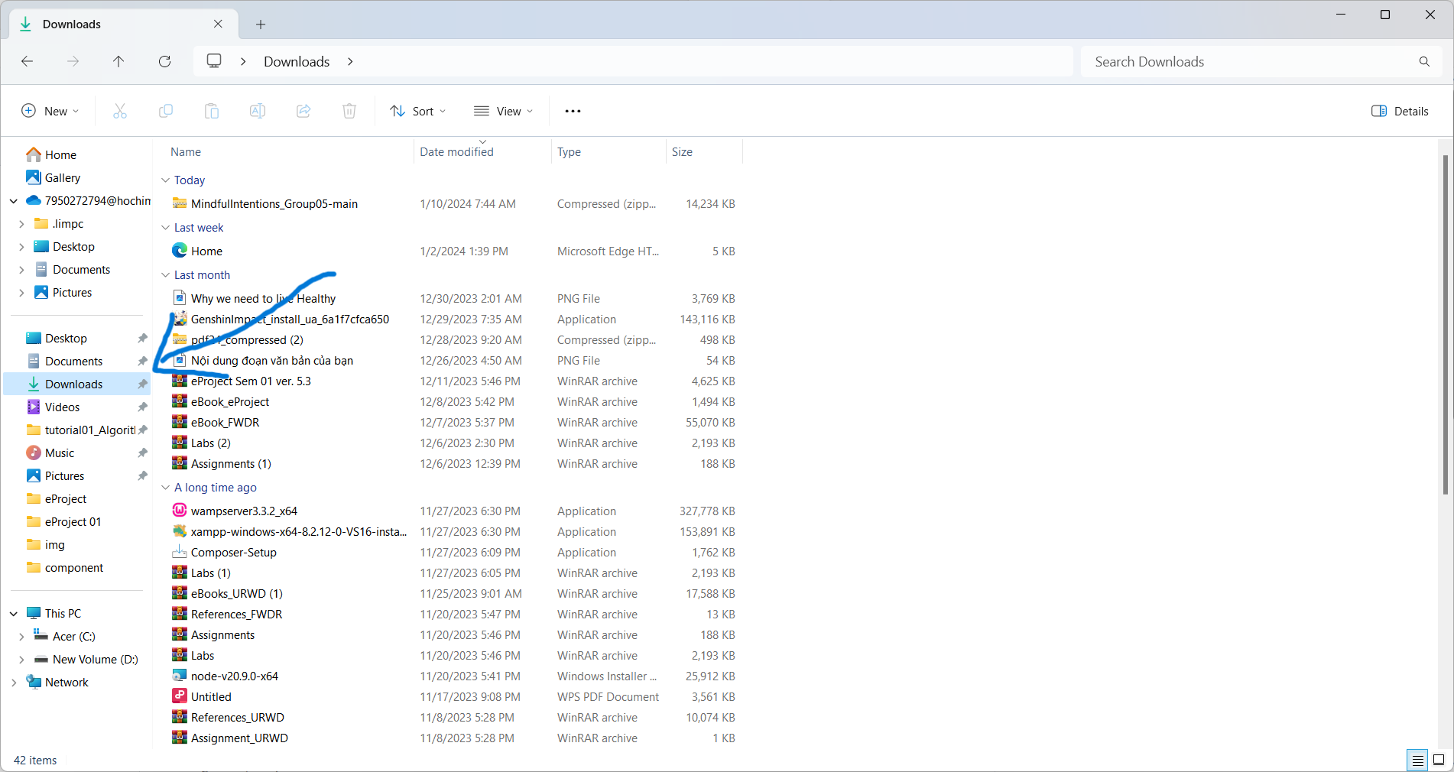
Click the zip package just downloaded:
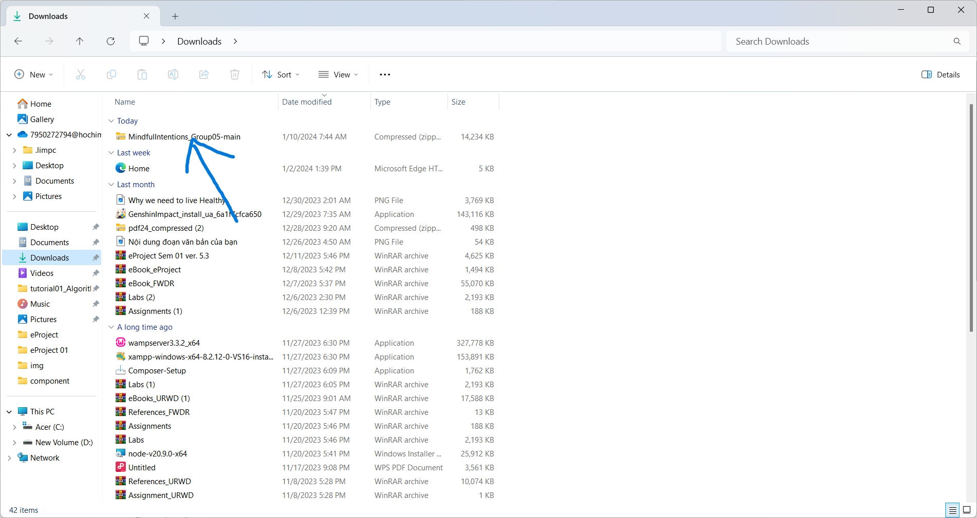
Press textright, select Extract All to extract the zip package.->Then you will receive a new folder that has just been extracted:
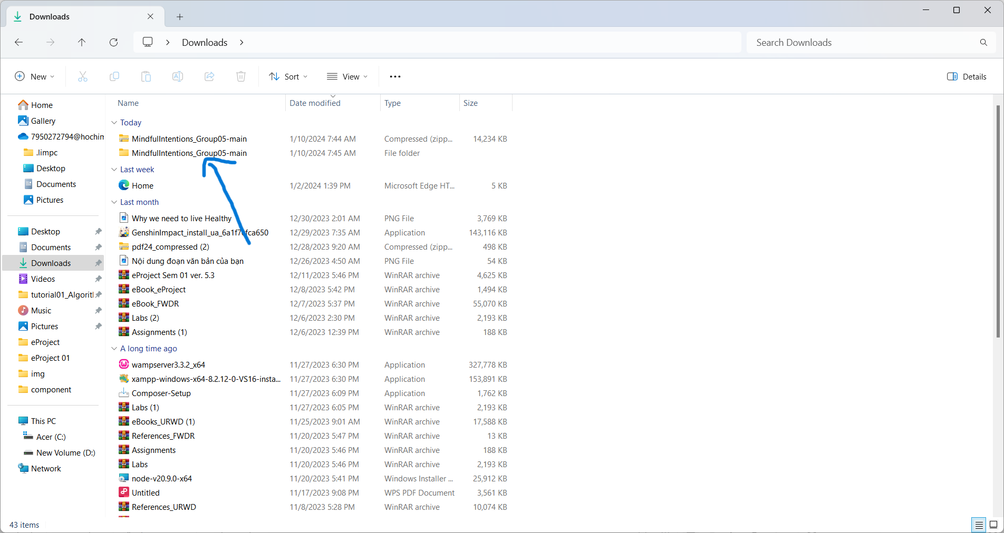
Step 3 . Click the folder just extracted->right-click-> Select Terminal-> enter "code." to open VScode :
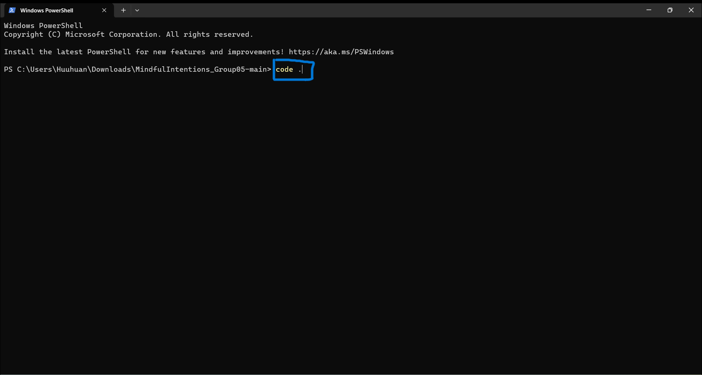
Step 4. At the VScode interface, click MindfulIntentions_Group05-main:
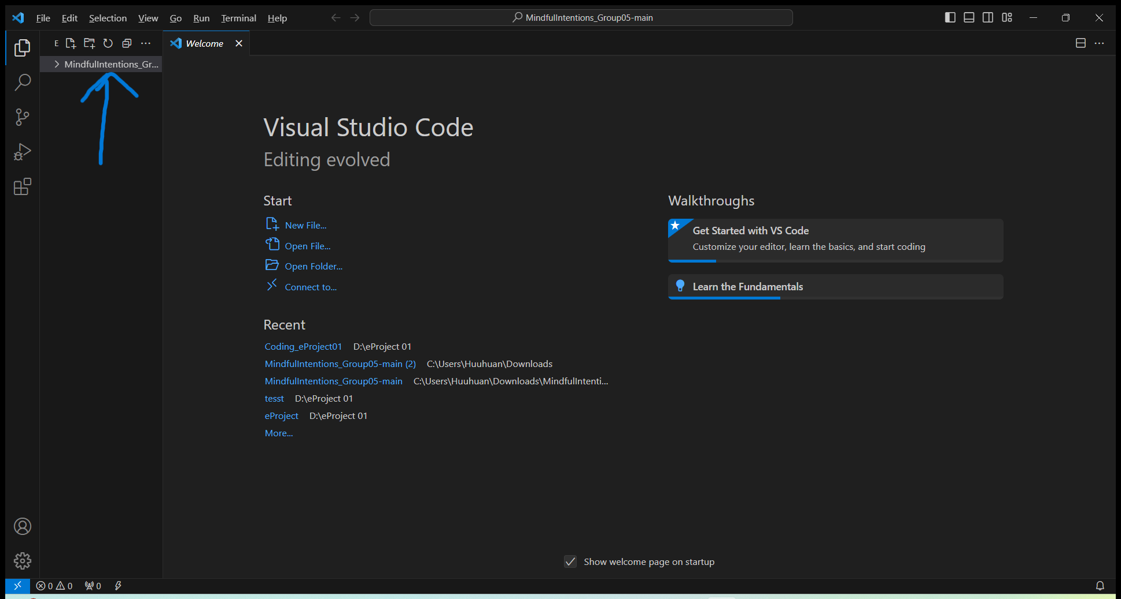
Click folder coding:
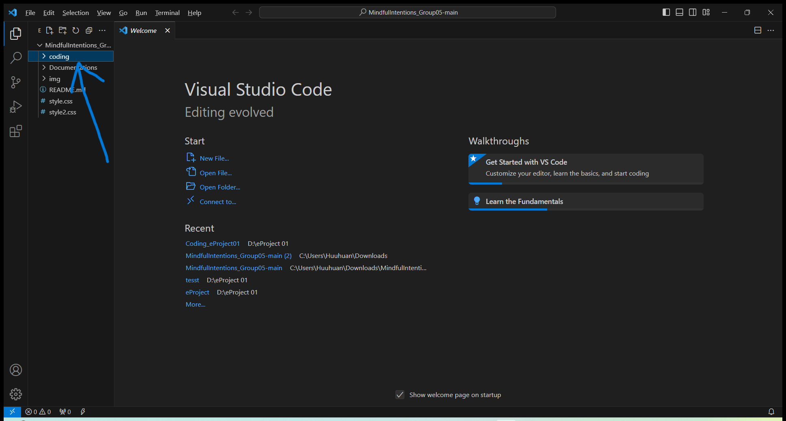
Click file Home.html ->Right-click > select “Open in default browser”.

C. Successful test
- The file is loaded successfully
- Homepage should be displayed as described in the documentation.
